If you ever decide, you want to move the server to a new location this guide will help you set up the new server. This guide will walk through the steps required to get the server up and running.

Before proceeding, it is advised to export the current database tables in order to maintain the current information. To do this, navigate to the phpMyAdmin interface and select the New database button. Next, the radio button labelled Custom – display all possible options should be checked. After that, in the databases category, select only the audioreadingservice database. Lastly, scroll to the bottom and click ‘Go’ and a file will be downloaded. This will serve as a backup of the database, which we can import later. Refer to Figure 1.

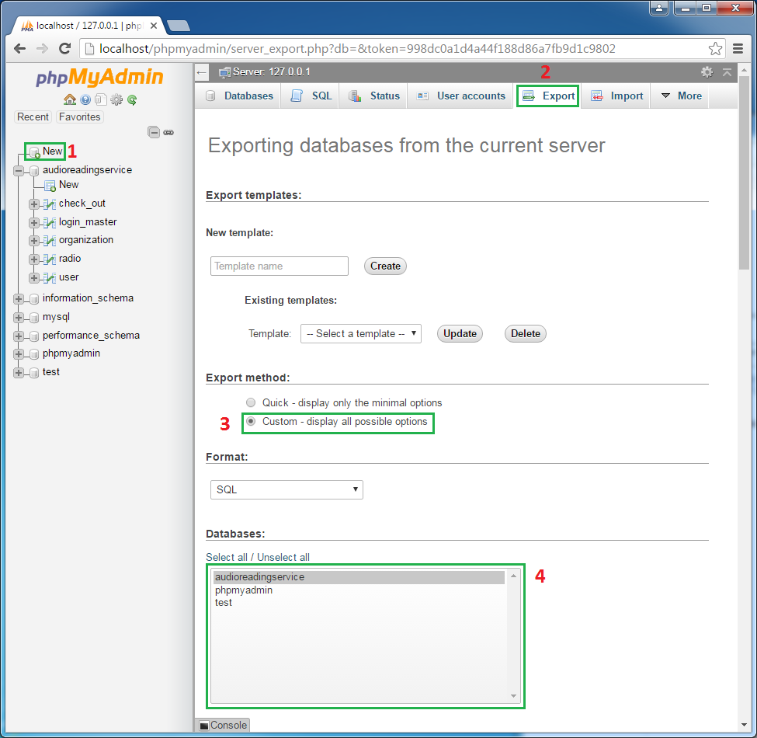

**Figure 1**

The proper order and selection for exporting the audioreadingservice database

1. Installing XAMPP
   1. You can download XAMPP from the following link: <https://www.apachefriends.org/index.html>
   2. In the event that the link no longer works, a simple google search for XAMPP should suffice.
   3. During the Installation, when you must select components, check everything as indicated in Figure 2.
   4. For the installation Directory, put it in the default location: C:\xampp
   5. Uncheck the box regarding Bitnami for XAMPP
   6. When asked about Window’s Firewall, allow Apache HTTP Server access.
   7. After the installation completes, click finish.

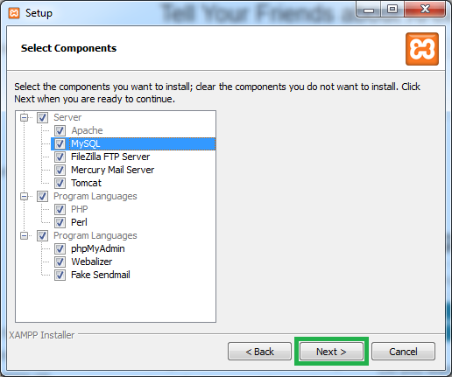

**Figure 2**

The selection during XAMPP installation

1. Starting XAMPP
   1. Once the installation finishes and you select the language you wish to use, we will start the Apache and MySQL modules by clicking the Start buttons for both of them.
   2. If prompted, allow MySQL access to the firewall
   3. Once everything starts successfully, you should get a picture similar to Figure 3.

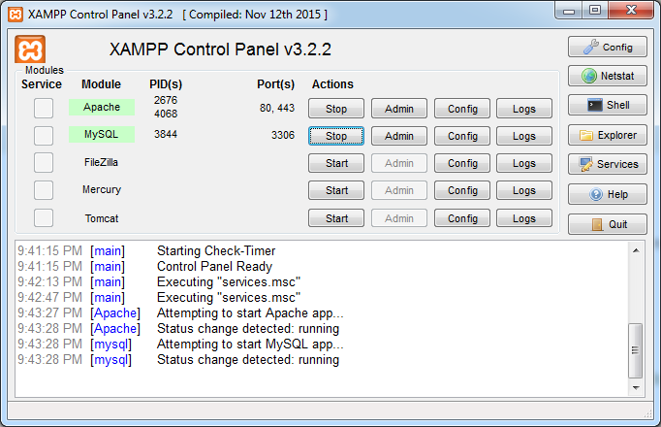

**Figure 3**

XAMPP running showing the required modules running successfully

1. Deploying the Code
   1. Next, we are ready to deploy the source code onto the server.
   2. Navigate to where the code-base is saved and download it onto the server.
   3. Extract the source code
   4. Select the following folders contained inside the code-base:
      1. application
      2. docs
      3. library
      4. nbproject
      5. public
      6. tests
      7. README.md
   5. Copy these folders into c:\xampp\htdocs\RadiosApp\ If this folder does not exist, create it.
   6. After copying the files finishes, the code is now in place to be accessed.
2. Preparing the database
   1. If you exported a backup of the database prior this is where we will import that file. Alternatively, if you did not export the database and do not care about its contents, you can run the CreateDatabase.sql file located in public/sql/buildScript/. This will create the database with all of the tables and their default columns, but no data will be imported.
   2. In the event that we are importing a backup, navigate to the phpMyAdmin page
   3. Select New on the left panel
   4. At the top, select Import
   5. Click the Choose File button and navigate to the .sql file we downloaded at the beginning of this guide.
   6. Lastly, click ‘Go’ and the database will be created with all of the information previously saved.

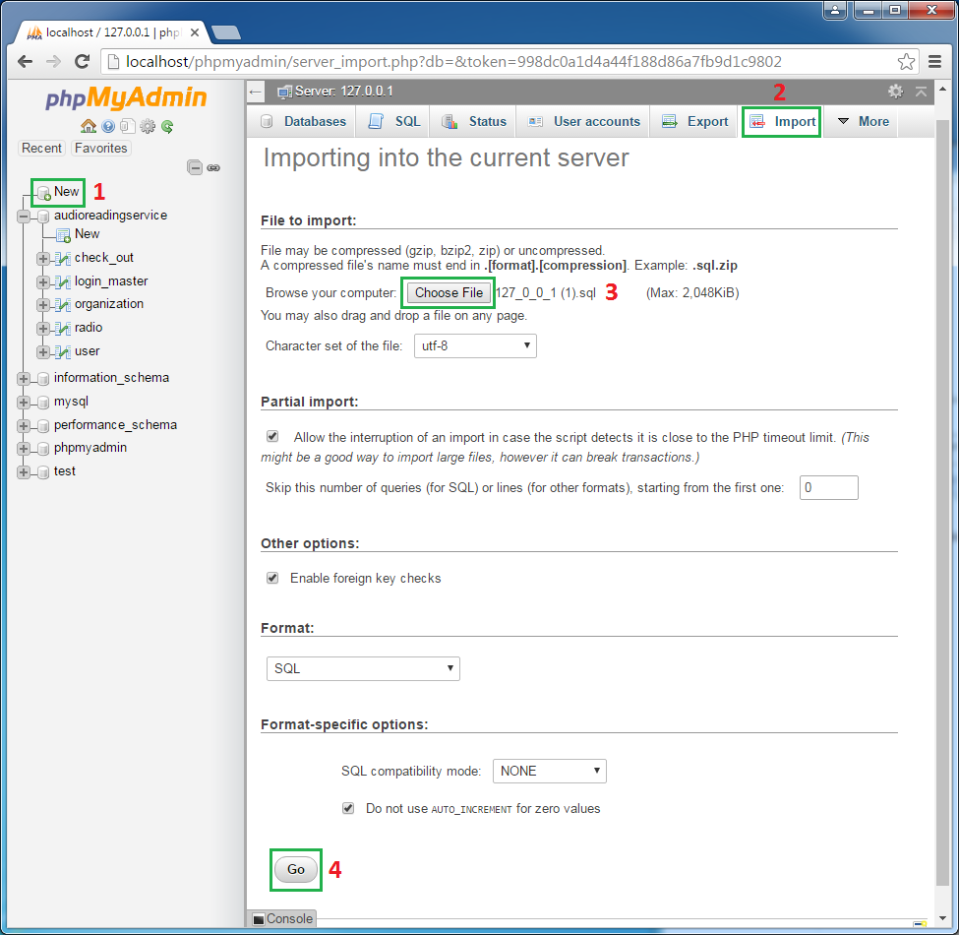

**Figure 4**

The steps required to import the file exported at the start of this guide

The Application should now be fully installed and ready for Listener interaction.